Two important properties a program can have:

* Readability
* Changeability

Defining constants

* (define [CONSTANT NAME] [constant expression/value])
* 
* 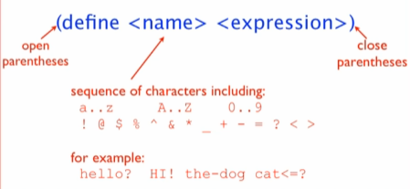

Evaluating constants

* 
* 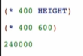
* 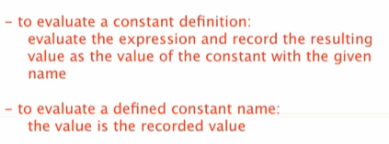

Other examples:

Constant image

Copy:

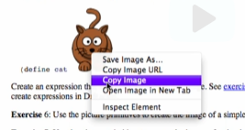

Paste:

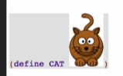

Try using image functions

 -> 

We can also use these expressions for defining constants



RCAT ->  LCAT -> 